Part A:- Multiple Choice [10 Points]
Circle the letter of the best choice.

- One of the advantages of database systems is that ___.
  - Database systems do not integrate many different users' data into a single all-encompassing data repository.
  - Database systems enable the data in the database to be shared among multiple applications or users.
  - Database systems maximizes data inconsistency
  - Database systems decreases end user productivity

- April is a database administrator, she wants to provide a description of the data characteristics and the set of relationships that link the data found within the database. What should she use?
  - Queries

  - End-user data
  - Metadata
  - Schemas

- The CUSTOMER table’s primary key is CUS_CODE. The CUSTOMER primary key column has no null entries, and all entries are unique. This is an example of _____ integrity.
  - entity
  - referential
  - relational
  - null

- Sally's Dog Grooming Salon is creating a database of every dog she grooms. She wants to collect specific information about the breed, height, weight, and age of each dog. What building block does "dog" represent in her data model?
  - attribute
  - relationship
  - entity
  - class

- Karl is in the process of identifying and documenting business rules during his step in a new database design, spending many hours ensuring its accuracy. Why would he spend a significant amount of time on one task?
  - It makes it easy to recognize the data contained in an attribute.
  - it enables company managers and policy makers to make informed decisions.
  - it identifies management problems within the company.
  - It helps to standardize the company's view of data.

- A _____ is the primary key of one table that has been placed into another table to create a common attribute.
  - superkey
  - composite primary key
  - candidate key
  - foreign key

- Which of the following simple-language expressions represents a valid constraint?
  - EMPLOYEE manages STORE
  - CUSTOMER generates INVOICE
  - STUDENT takes CLASS
  - Each CONTAINER contains between 0 and 100 UNITs.

- In a PROFESSOR and COURSE relationship if the PROFESSOR object is given a cardinality of (1,1), then which of the following would be a true statement about the university?
  - A PROFESSOR must have more than one COURSE to teach
  - A PROFESSOR can optionally teach a COURSE
  - A COURSE must have at least one PROFESSOR to teach
  - A COURSE can optionally have a PROFESSOR to teach

- If we are creating subtypes for a car dealership. Why would an accountant be a subtype of an employee?
  - because it is identifiable with employees and has unique attributes
  - because it only is identifiable with employees
  - because it is not identifiable with employees but has unique attributes
  - because it only has unique attributes

- In organizations that generate large number of transactions, _____ are often a top priority in database design.
  - relationships among entities
  - logical design standards
  - naming conventions
  - high processing speeds
Part B:- Answer all 3 questions in spaces provided.

Question 1:- Use the database tables shown to answer Problems (a) to (d) below. [10 Points]

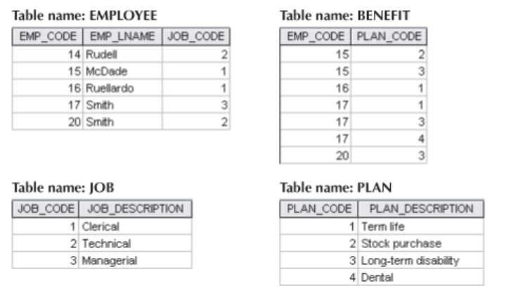
- An EMPLOYEE has only one JOB_CODE, but a JOB_CODE can be held by many EMPLOYEEs.

- An EMPLOYEE can participate in many PLANs, and any PLAN can be assigned to many EMPLOYEEs.

Each employee is assigned to exactly one job, but a job can be held by many employees. This establishes a one-to-many (1:M) relationship between JOB and EMPLOYEE.
Accordingly, the EMPLOYEE table uses EMP_CODE as its primary key and includes JOB_CODE as a foreign key referencing JOB(JOB_CODE).
Each employee can participate in multiple benefit plans, and each plan can be assigned to multiple employees. This defines a many-to-many (M:N) relationship between EMPLOYEE and PLAN.
To resolve this relationship, the BENEFIT table functions as an associative (bridge) entity, containing a composite primary key (EMP_CODE, PLAN_CODE). Both attributes also serve as foreign keys, referencing EMPLOYEE(EMP_CODE) and PLAN(PLAN_CODE) respectively. Finally, the JOB and PLAN tables act as reference (lookup) tables, each having its own primary key and no foreign keys.
- For each table in the database, identify the primary key and the foreign key(s). If a table does not have a foreign key, write None in the space provided. [3 Points]

TABLE | PRIMARY KEY(s) | FOREIGN KEY(s)
EMPLOYEE | EMP_CODE | JOB_CODE → JOB(JOB_CODE)
BENEFIT | (EMP_CODE, PLAN_CODE) | EMP_CODE → EMPLOYEE(EMP_CODE); PLAN_CODE → PLAN(PLAN_CODE)
JOB | JOB_CODE | None
PLAN | PLAN_CODE | None

- Create the relational diagram to show the relationships among EMPLOYEE, BENEFIT, JOB and PLAN
[3 Points]

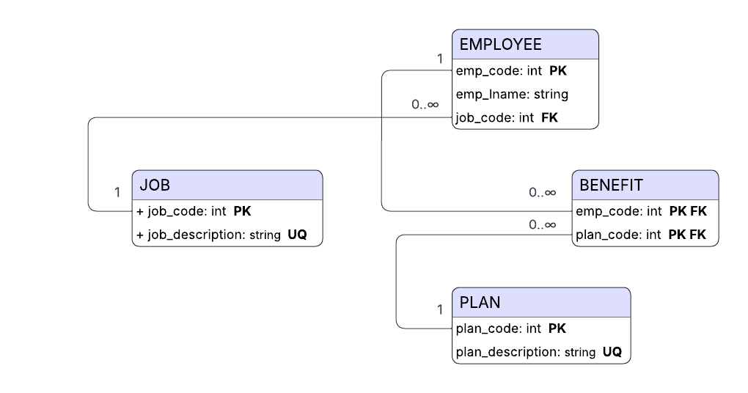
- Create the Crow’s Foot ERD to show the relationships among EMPLOYEE, BENEFIT, JOB and PLAN
[4 Points]
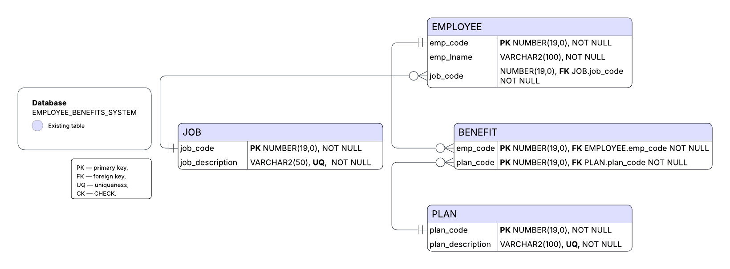
Business Rules:
1. Employee–Job Relationship
- Each Employee must have exactly one Job.
- Each Job can be assigned to many Employees.
- The relationship between JOB and EMPLOYEE is one-to-many (1:N).
- The foreign key job_code in the EMPLOYEE table references the JOB table.

2. Employee–Plan Relationship (through Benefit)
- An Employee can participate in many Plans.
- A Plan can be assigned to many Employees.
- The relationship between EMPLOYEE and PLAN is many-to-many (M:N).
- This relationship is implemented by the BENEFIT table, which serves as a bridge entity.
- The BENEFIT table uses a composite primary key (emp_code, plan_code) that also acts as foreign keys referencing both EMPLOYEE and PLAN.

3. Job Entity Rules
- Each Job has a unique identifier job_code (Primary Key).
- Each Job must have a unique job description.
- A Job can exist without having employees assigned (optional participation).

4. Plan Entity Rules
- Each Plan has a unique identifier plan_code (Primary Key).
- Each Plan must have a unique plan description.
- A Plan can exist without being assigned to any employees (optional participation).

5. Employee Entity Rules
- Each Employee has a unique identifier emp_code (Primary Key).
- Each Employee must have a last name (emp_lname) recorded.
- Each Employee must be assigned to exactly one Job (mandatory relationship).
- Each Employee may or may not have any Benefit Plans (optional participation).

6. Benefit Entity Rules
- The BENEFIT table defines the relationship between EMPLOYEE and PLAN.
- The combination of (emp_code, plan_code) uniquely identifies each benefit record.
- Both emp_code and plan_code are foreign keys referencing EMPLOYEE and PLAN, respectively.
- If an employee or plan is deleted, related benefit records should also be handled appropriately (e.g., cascade delete or restrict).

Question 2:- [10 Points]
Create an ERD using the Specialization Hierarchy (discussed in Chapter 5):-

- An employee could be staff, a professor, or an administrator.

- A professor may also be an administrator.

- Staff employees have a work-level classification, such as Level I or Level II.

- Only professors can chair a department. A department is chaired by only one professor.

- Only professors can serve as the dean of a college. Each of the university’s colleges is served by one dean.

- A professor can teach many classes.

- Administrators have a position title.

Given that information, create the complete ERD that contains all primary keys, foreign keys, and main attributes.
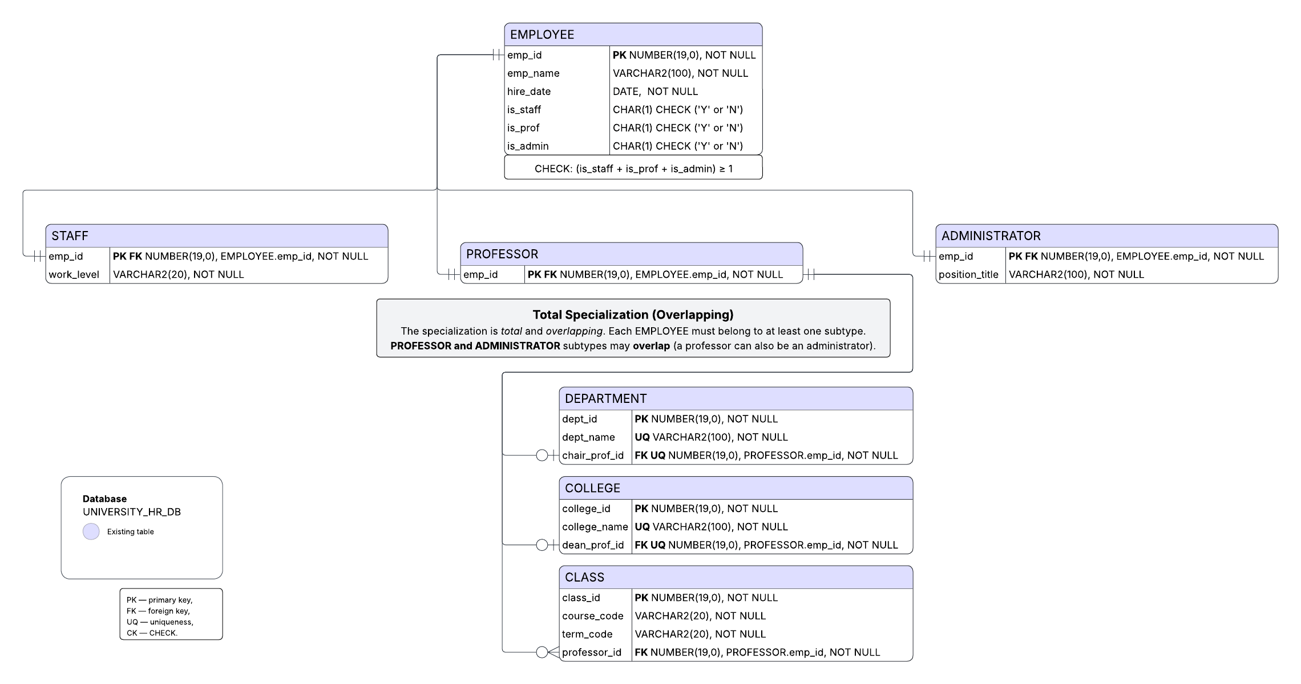

Business Rules:
Specialization & constraints:
- The data model defines a supertype EMPLOYEE and the subtypes STAFF, PROFESSOR, and ADMINISTRATOR.
- Total specialization holds: every EMPLOYEE must belong to at least one subtype.
- Overlapping is allowed between PROFESSOR and ADMINISTRATOR (the same employee may be both).
- STAFF is disjoint from the other subtypes (an employee classified as STAFF is not simultaneously PROFESSOR or ADMINISTRATOR).
- Each subtype inherits the primary key and relationships of EMPLOYEE; at implementation level, each subtype has a 1:1 identifying relationship to EMPLOYEE using the same emp_id as PK and FK.

Keys and identifying relationships:
- EMPLOYEE(emp_id) is the primary key of the supertype.
- STAFF(emp_id), PROFESSOR(emp_id), and ADMINISTRATOR(emp_id) each use emp_id as PK and FK → EMPLOYEE(emp_id) (identifying; 1:1).
- Subtype-specific attributes include: STAFF.work_level (e.g., ‘Level I’, ‘Level II’) and ADMINISTRATOR.position_title.

Professor roles and organizational entities
- Only a PROFESSOR can chair a department. Each DEPARTMENT is chaired by exactly one professor; a professor chairs at most one department.
Implementation: DEPARTMENT.chair_prof_id UNIQUE NOT NULL FK → PROFESSOR(emp_id).
- Only a PROFESSOR can serve as dean. Each COLLEGE has exactly one dean; a professor is dean of at most one college.
Implementation: COLLEGE.dean_prof_id UNIQUE NOT NULL FK → PROFESSOR(emp_id).
- A PROFESSOR may teach many classes; each CLASS is taught by exactly one professor.
Implementation: CLASS.professor_id NOT NULL FK → PROFESSOR(emp_id).

Participation and integrity notes:
- Participation of DEPARTMENT and COLLEGE in their role relationships is mandatory (exactly one) on the entity side and optional (0 or 1) on the professor side (enforced with UNIQUE on the professor FK).
- The total specialization can be enforced at the table level by a check such as “at least one subtype flag is true” (e.g., is_staff, is_prof, is_admin) or by application logic/triggers.
- Overlapping between PROFESSOR and ADMINISTRATOR implies the model allows the same emp_id to appear in both subtype tables simultaneously.

Question 3:- [10 Points]

A friend of yours has opened Professional Electronics and Repairs (PEAR) to repair smartphones, laptops, tablets, and MP3 players. She wants you to create a database to help her run her business.

- When a customer brings a device to PEAR for repair, data must be recorded about the customer, the device, and the repair. The customer’s name, address, and contact phone number must be recorded (if the customer has used the shop before, the information already in the system for the customer is verified as being current). For the device to be repaired, the type of device, model, and serial number are recorded (or verified if the device is already in the system). Only customers who have brought devices into PEAR for repair will be included in this system.

- Because a customer might sell an older device to someone else who then brings the device to PEAR for repair, it is possible for a device to be brought in for repair by more than one customer. However, each repair is associated with only one customer. When a customer brings in a device to be fixed, it is referred to as a repair request, or just “repair,” for short. Each repair request is given a reference number, which is recorded in the system along with the date of the request, and a description of the problem(s) that the customer wants fixed. It is possible for a device to be brought to the shop for repair many different times, and only devices that are brought in for repair are recorded in the system. Each repair request is for the repair of one and only one device. If a customer needs multiple devices fixed, then each device will require its own repair request.

- There are a limited number of repair services that PEAR can perform. For each repair service, there is a service ID number, description, and charge. “Charge” is how much the customer is charged for the shop to perform the service, including any parts used. The actual repair of a device is the performance of the services necessary to address the problems described by the customer. Completing a repair request may require the performance of many services. Each service can be performed many different times during the repair of different devices, but each service will be performed only once during a given repair request.

- All repairs eventually require the performance of at least one service, but which services will be required may not be known at the time the repair request is made. It is possible for services to be available at PEAR but that have never been required in performing any repair.

- Some services involve only labor activities and no parts are required, but most services require the replacement of one or more parts. The quantity of each part required in the performance of each service should also be recorded. For each part, the part number, part description, quantity in stock, and cost is recorded in the system. The cost indicated is the amount that PEAR pays for the part. Some parts may be used in more than one service, but each part is required for at least one service.

Create an Entity Relationship Diagram (ERD) using the Crow’s Foot Notation to represent all the Entities, relationships. For maximum scores, make sure to clearly label your entities, relations, primary key, foreign key, any weak or strong relations. For the entities, be sure to at least indicate the Primary Key and Foreign key. If there are any M:N relations, create a composite entity to break the M:N into a 1:M or 1:1 relation.

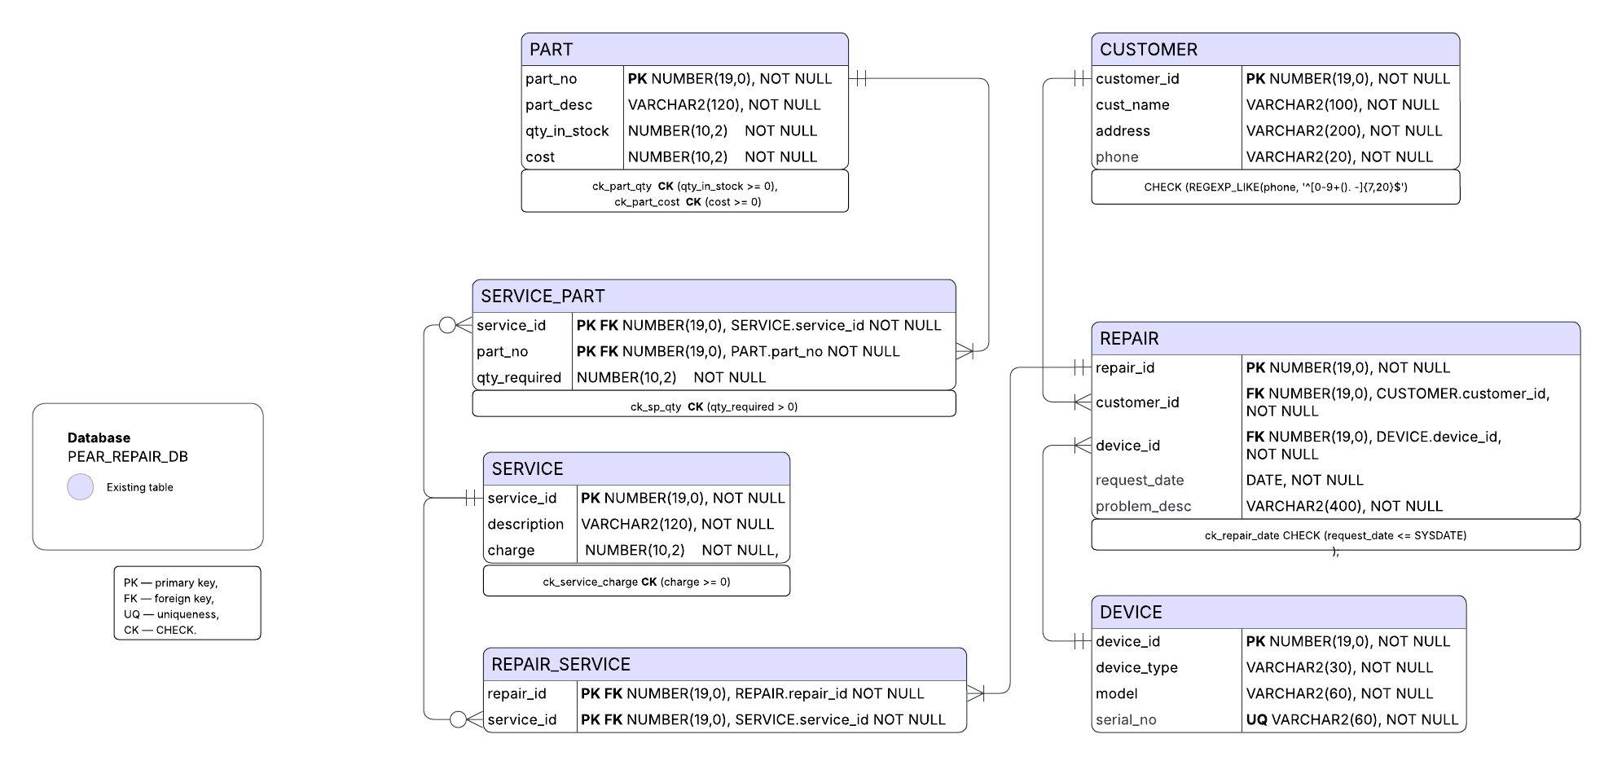

Business Rules:
- Customer Information
  - Only customers who have brought devices to PEAR for repair are recorded in the system.
  - Each CUSTOMER may submit one or many REPAIR requests (1:M relationship).
  - Each REPAIR request must belong to exactly one CUSTOMER (mandatory participation).
  - A customer’s data (name, address, phone) must be verified if the customer already exists in the system.
  - Customers cannot exist in the database without having at least one associated repair.

- Device Information
  - Only devices that have been brought to PEAR for repair are recorded in the system.
  - Each DEVICE can be repaired many times over its lifetime (1:M relationship).
  - Each REPAIR is linked to exactly one DEVICE (mandatory participation).
  - Devices are identified by a unique serial number, ensuring that the same physical device can be traced across multiple repairs, even if owned by different customers.
  - A device may appear in repair requests from different customers (ownership can change).

- Repair Requests
  - Each REPAIR represents a single repair request for one device brought in by one customer.
  - If a customer brings multiple devices, each requires its own repair record.
  - For each REPAIR, the following information is stored: unique repair ID, request date, and problem description.
  - The request_date must be less than or equal to the current date (CHECK (request_date <= SYSDATE)).
  - Each repair request must eventually include at least one performed SERVICE, but the exact services may not be known at the time the repair is created.
  - The M:N relationship between REPAIR and SERVICE is resolved by the associative entity REPAIR_SERVICE(repair_id, service_id).

- Service Information
  - PEAR offers a limited catalog of repair services stored in SERVICE.
  - Each service has a unique service_id, a textual description, and a charge amount (the price to the customer, including labor and parts).
  - A SERVICE can be performed in zero or many different repairs (optional participation).
  - Within a single repair, a given service can appear only once, enforced by the composite PK (repair_id, service_id) in REPAIR_SERVICE.
  - Each repair must include at least one service (mandatory participation on the REPAIR side).
  - Business rule enforcement: “Each repair must include ≥ 1 service” can be implemented through application logic or a completion trigger on REPAIR.

- Parts and Inventory
  - The PART table stores all parts that PEAR uses for repairs.
  - Each part has a unique part_no, a description, the quantity_in_stock, and a cost (the amount PEAR pays to obtain it).
  - Both cost and quantity_in_stock must be non-negative (CHECK (cost >= 0, qty_in_stock >= 0)).
  - Some services may not require any parts (labor-only), but most do.
  - The relationship between SERVICE and PART is many-to-many and resolved through the associative entity SERVICE_PART(service_id, part_no), which also records qty_required (must be greater than zero).
  - Every PART must be associated with at least one SERVICE (mandatory participation on the PART side).

- Entity Strength and Keys
  - Strong Entities:
    - CUSTOMER(customer_id PK)
    - DEVICE(device_id PK)
    - REPAIR(repair_id PK, customer_id FK, device_id FK)
    - SERVICE(service_id PK)
    - PART(part_no PK)
  - Weak (Associative) Entities:
    - REPAIR_SERVICE(repair_id FK, service_id FK, PK = (repair_id, service_id)) — represents which services are performed in each repair.
    - SERVICE_PART(service_id FK, part_no FK, PK = (service_id, part_no), qty_required > 0) — represents which parts are required and in what quantity for each service.

